Fairness Risk Assessment: Identifying and Mitigating Stealth Disparate Impact
Selena Owen
This essay examines fairness risks across a three-part experimental analysis: data poisoning attacks, membership inference privacy leakage, and differential privacy. The single highest-risk finding is identified, two mitigations; one proactive, one reactive are proposed and quantified, and disparate impact trade-offs are discussed.

Highest-Risk Finding: Stealth Data Poisoning on African American Defendants
The most dangerous finding is that label-flipping poisoning attacks targeting African American (AA) defendants inflate the Adverse Impact Ratio (AIR) from 1.96 to 3.01 at a 30% poison rate while AUC degrades by only 0.0034—well within the two-percentage-point stealth zone. This means an adversary can inject severe racial bias that standard model-performance monitoring would miss entirely. By contrast, poisoning targeting Caucasian (CA) defendants barely moves AIR (1.96 → 1.94 at 30%), confirming the asymmetric vulnerability. The attack makes the model systematically favor AA defendants in classification, artificially inflating the favorable-outcome rate for that group while overall accuracy appears stable.

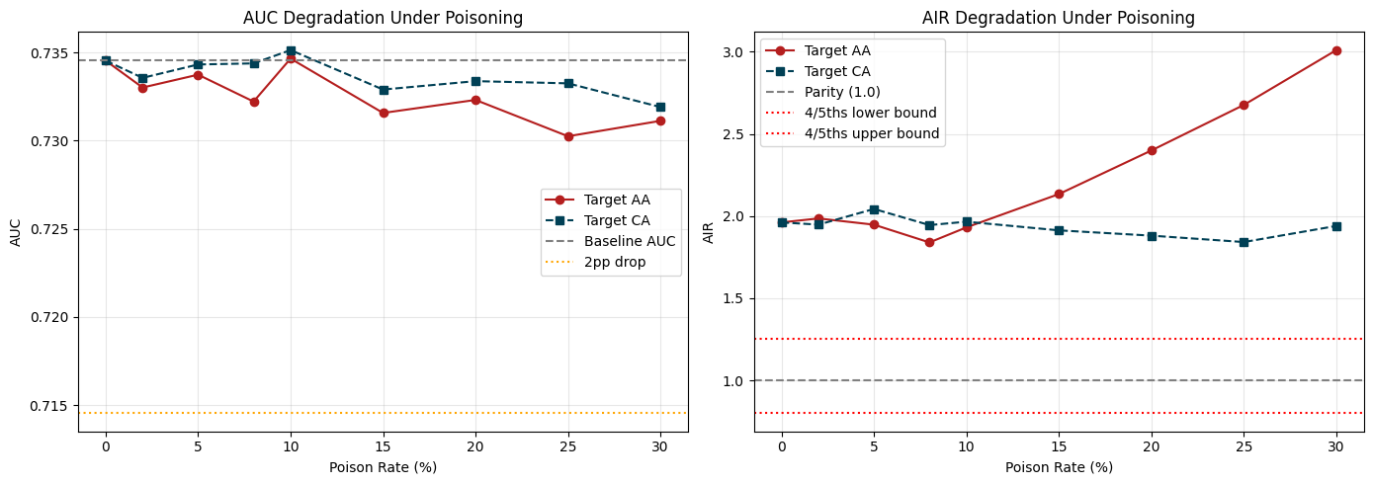
Figure 1. AUC and AIR degradation under increasing poison rates for AA and CA targets

Proactive Mitigation: L2 Regularization to Limit Information Leakage
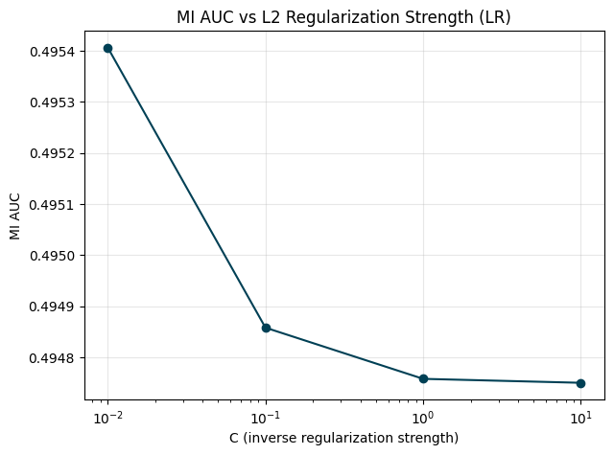
Stronger L2 regularization (lower C) reduces membership inference risk. Experimental results show MI AUC drops from 0.4954 at C = 0.01 to 0.4948 at C = 10.00 for logistic regression and all values near the 0.50 random-guess baseline, indicating minimal privacy leakage. The LR model's generalization gap is −0.0077, confirming it does not overfit. By contrast, GBT shows MI AUC = 0.545 and a generalization gap of +0.080, indicating meaningful memorization. Regularization hardens models against both membership inference and the gradient signals poisoning attacks exploit, making stealth attacks harder to sustain without detection.

Figure 2. MI AUC as a function of L2 regularization strength ( C ) for logistic regression.

Reactive Mitigation: Continuous AIR Monitoring with 4/5ths Bounds
A reactive post-deployment audit should monitor AIR against the EEOC 4/5ths rule bounds (0.80–1.25) at regular intervals. The poisoning results show AIR for AA-targeted attacks exceeds the upper bound by poison rate = 20% (AIR = 2.40), providing a clear detection signal. A monitoring dashboard that flags AIR exceedances would have caught this drift before the 30% level (AIR = 3.01). The audit should also recompute FPR by group under differential privacy; at ε = 0.25, LR yields FPR_{AA} = 0.569 and FPR_{CA} = 0.370 (AIR = 1.535), confirming the 4/5ths threshold is maintained even under strict privacy budgets.

Disparate Impact Trade-Offs
Two trade-offs emerge. First, differential privacy equalizes outcomes at the cost of utility: at ε = 0.25, both groups' FPRs rise sharply (FPR_{AA} from baseline to 0.569; FPR_{CA} to 0.370), meaning more defendants of both races are incorrectly flagged high-risk. At ε = 2.00, FPR reaches 1.000 for both groups—complete fairness at total loss of predictive power. Second, GBT resists differential-privacy noise better (FPR stabilizes at ε ≥ 0.50) but leaks more membership information (MI AUC = 0.545 vs. LR's 0.495). Model selection thus involves a privacy–fairness–accuracy trilemma with no globally optimal solution.

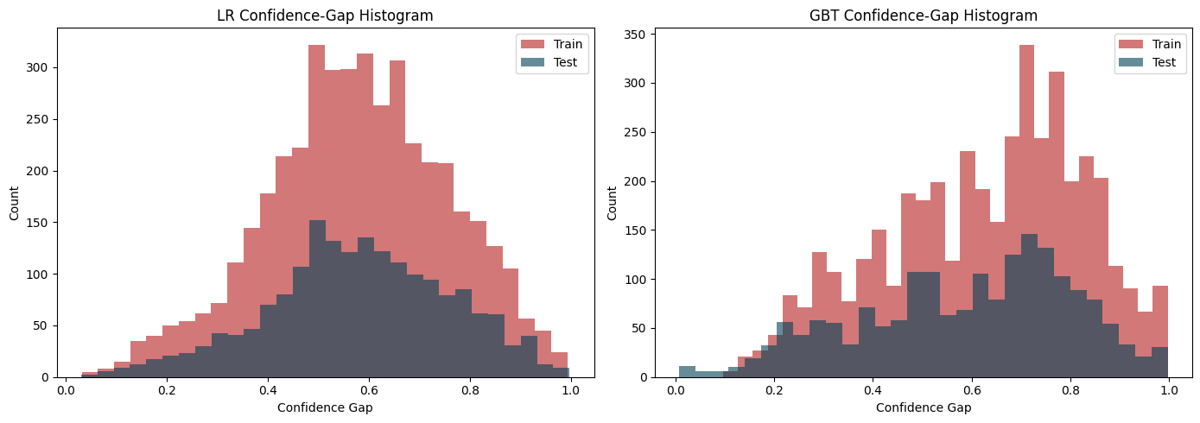
Figure 3. Confidence-gap distributions for LR and GBT illustrating GBT’s wider train-test gap and higher memorization risk.

Conclusion

Stealth data poisoning targeting AA defendants is the single highest-risk finding because it introduces severe disparate impact undetectable by AUC monitoring alone. L2 regularization proactively hardens models against both privacy leakage and poisoning, while continuous AIR monitoring reactively catches fairness drift before it accumulates. Deploying both mitigations together addresses the privacy–fairness–accuracy trilemma from complementary angles.

